Accountable Care Enterprise Limited, the Brambles Surgery, Geary Drive, Brentwood CM15 9DY

**Where do I go for my appointment?**

The service is located on the ground floor

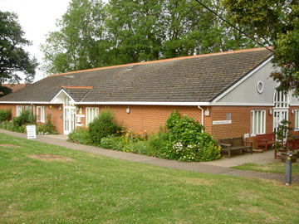

This information can be made available in alternative formats, such as easy read or large print, and may be available in alternative languages, upon request. Please contact ace.ltd@nhs.net

*Published April 2018*

**ACE Limited GP Federation**

The GP Extended Access Service is provided by Accountable Care Enterprise. Accountable Care Enterprise is wholly owned by the GP practices in Brentwood, working together on behalf of practices, patients, and staff to deliver safe, effective and responsive healthcare services.

GP Extended Access Bookable Service

More GP and nurse

Appointments in Brentwood

6.30pm - 8pm Mon-Fri

9.00am – 3pm Saturday

10.00am -2pm Sunday

**GP Extended Access Bookable appointment Service**

There are now more appointments with GPs and nurses available in Brentwood, making it easier for you to get an appointment at a time that suits you in the evenings and weekends

**When are these appointments available?**

Appointments are available from 6.30 – 8 pm Monday to Friday, 9am – 3pm Saturday and 10am – 2pm on Sunday.

**Who can access these appointments?**

Anyone registered with a GP practice in Brentwood.

**How do I book a GP or nurse appointment?**

Contact your GP practice in the usual way to request an appointment. If there are no appointments available at your practice, they may offer you an appointment with the GP Extended Access Service, if this is right for you.

If your practice is closed and you need a GP, please contact NHS **111**. **If urgent care is required, please call ‘111’ for further advice. If your need is life threatening, please go to A&E or call 999.**

**Will I see my own GP and/or nurse?**

You will be seen by registered GPs and nurses, but it is unlikely that you will be seen by your own GP or nurse. If you would prefer to see your usual GP or practice nurse, please book an appointment with your usual practice during their normal opening hours.

**Will the GP/nurse I see have access to my medical record during my appointment?**

Your medical record will, with your consent, be available to the GP/ nurse that sees you, to ensure that they have the information they need to give you the best possible care.

Notes of your appointment will be sent back to your own GP practice electronically to ensure that your record is up-to-date.

**How do I cancel an appointment?**

**If you need to cancel an appointment, please call 07757719333 and leave a message stating your name and the time and date of your appointment with the GP Extended Access Service.**

**What can I be seen for?**

A GP Extended Access appointment is exactly like an appointment at your own GP practice. The service can see babies and children and has nurse appointments for treatments such as wound care, vaccinations, etc.